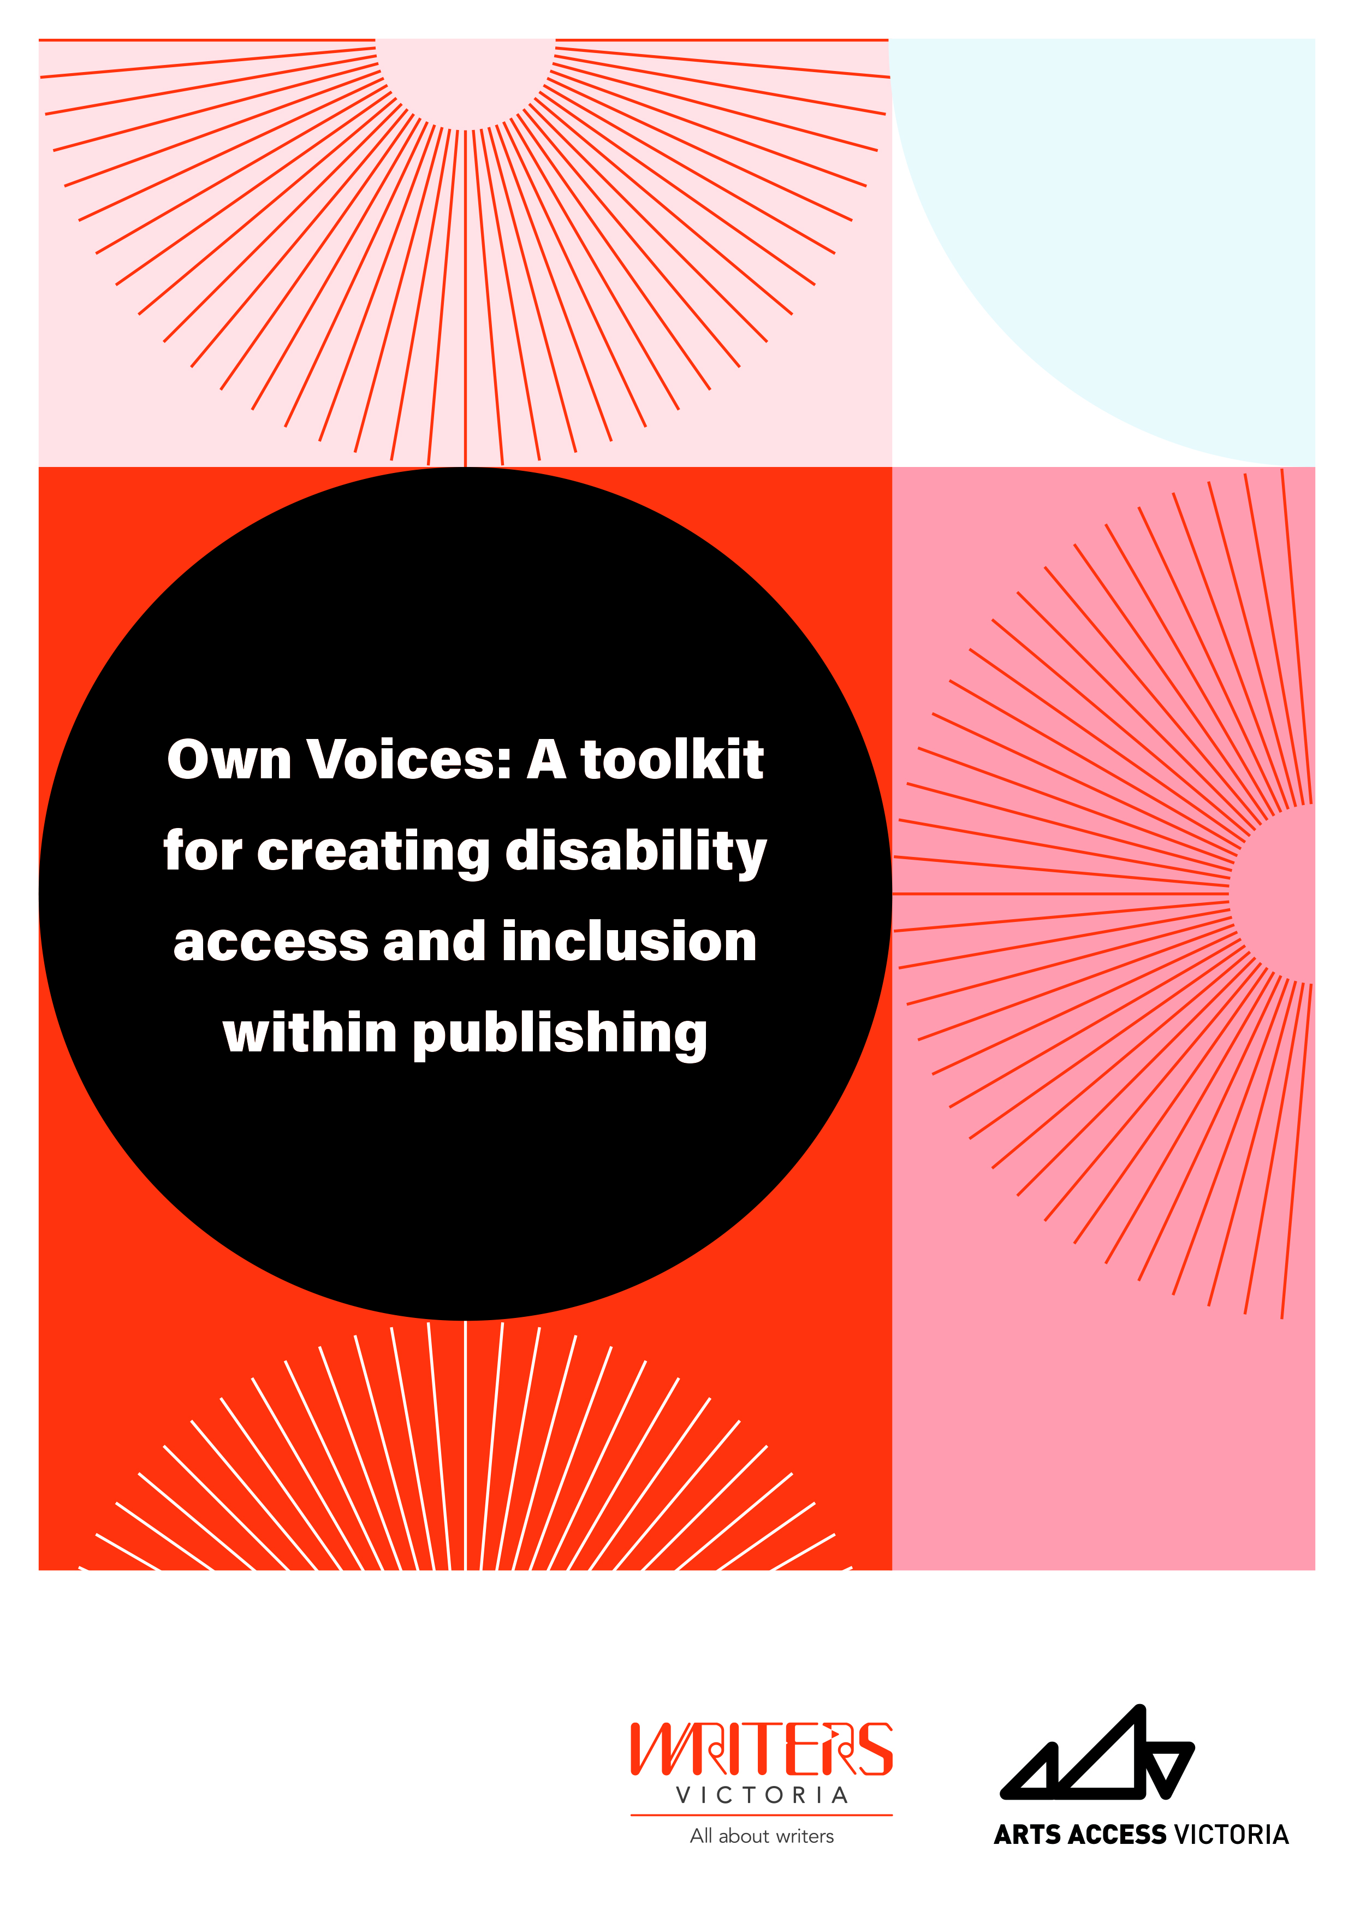

Own Voices: A toolkit for creating disability access and inclusion within publishing

Contents

Acknowledgements 5

A note on language 5

Introduction 7

What is disability? 9

Is disability a medical diagnosis? 9

I don’t feel comfortable calling someone Disabled, isn’t it more polite to just say ‘person with disabilities’? 9

Why have you used the phrase ‘d/Deaf and Disabled’? Aren’t deaf people Disabled? 10

Activity: The Social Model of Disability 11

Disability and the arts 12

How can you help break down the barriers? 13

How do I know if someone identifies with disability if 80% are invisible? 14

Activity: Thinking about your workplace 14

Finding d/Deaf and Disabled writers 16

What is ‘Own Voices’? 16

Activity: Where are all the d/Deaf and Disabled writers? 16

Activity: The Fries Test 16

Intersectionality 17

What is ableism? 18

Activity: Finding d/Deaf and Disabled writers 18

Where to find d/Deaf and Disabled writers? 18

Working with d/Deaf and Disabled writers 22

Activity: Asking about access 22

Language and disability 23

Important things to remember 24

When should I capitalise Deaf? 24

Language do’s and don’ts 26

Additional resources 27

Activity: Avoiding inspiration porn 28

Promoting d/Deaf and Disabled writers 30

Accessible social media 30

Activity: Creating an author bio 31

Activity: Examples of good access information pages 32

Creating an inclusive organisation 33

Individual attitudes and behaviours 33

Personal action plan 34

Employment 35

Targets 36

Useful services and organisations 38

Services for people who are blind or have low vision 40

Services for people who are d/Deaf or hard of hearing 42

Other organisations and services 43

Marketing and communications 44

Disability literature websites 45

Disability in Kidlit 45

Disability Literature Resources List 45

Podcasts 45

Magazines and online journals 45

Further reading by d/Deaf and Disabled writers 45

# Acknowledgements

This toolkit was developed on the lands of the Wurundjeri people of the Kulin Nations. We wish to pay our respects to their elders—past, present and emerging. This land was never ceded and the process of colonisation, incarceration and genocide which began over two centuries ago continues to this day. In the face of this we want to recognise the strength, resilience and pride of Aboriginal and Torres Strait Islander people. Always was and always will be Aboriginal land.

We encourage you to read more about the intersection of disability and Aboriginal and Torres Strait Islanders identities and advocacy issues by visiting the [First Peoples Disability Network Australia](https://fpdn.org.au) website.

“We have a vision of a just and inclusive society, in which the First Peoples with disability of the Australian nation are respected and valued for their culture, history and contribution to contemporary life, and in which the human rights of First Peoples with disability are recognised, respected, protected and fulfilled’’. – First Peoples Disability Network Australia

Publishability was a partnership between Writers Victoria and Arts Access Victoria, funded by Creative Victoria’s Talent Matters program.

We wish to extend a heart-felt thank you to all the publishers and editors who attended our ‘Publishability: Disability Equality Training’ across the life of the program and who provided suggestions on the content of this toolkit. We hope that this toolkit will be useful for all who work in the publishing industry, including publishers, editors, publicity and marketing, and booksellers.

Finally, we want to say a big thank you to Jax Jacki Brown, Fiona Murphy and Phoebe Neilson for their brilliant and creative work on the pages that follow.

Creative Victoria logo

Unesco United Nations Educational, Scientific and Cultural Organization Melbourne City of Literature.

## A note on language

Throughout this toolkit you will notice that we use the terms d/Deaf and Disabled. These terms are linked to a cultural identity and experience known as the Social Model of Disability, which was developed by Mike Oliver in 1983. The Social Model of Disability states that many of the barriers that d/Deaf and Disabled people experience are not due to their bodies and minds being different, but instead due to structural and societal barriers which hinder access and inclusion. Barriers can be environmental, such as inaccessible buildings, transport, housing or employment opportunities. Barriers can be attitudinal. Some common stereotypes include framing disability as a terrible tragedy with Disabled people considered objects of pity or charity. The Social Model of Disability enables us to begin to notice these stereotypes, attitudes and the barriers in our environment and advocate for a more accessible and inclusive society. The Social Model of Disability also allows individuals to identify how they want to identify, so while we use the terms d/Deaf and Disabled throughout the toolkit, please keep in mind that it is best practice to ask an individual how they wish to identify.

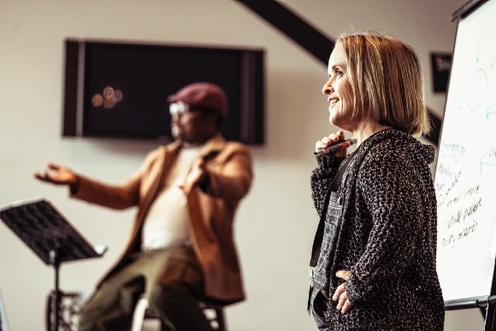

Arts Access Victoria training. Image supplied.

# Introduction

The Own Voices Toolkit is a practical resource for the Australian publishing industry about how to improve access and inclusion for d/Deaf and Disabled people.

The toolkit was developed following a series of ‘Publishability: Disability Equality Training’ workshops throughout 2018–2020. Publishability is a partnership between Writers Victoria and Arts Access Victoria, funded by Creative Victoria’s Talent Matters program. It builds on the Write-ability program, which has been running for over eight years. Write-ability provides mentorship and skills development for five d/Deaf and Disabled writers each year. The Publishability program has enabled four writers who have undertaken a Write-ability fellowship to continue to work on a manuscript and bring it to the attention of publishers. Publishability is a ground-breaking initiative, which aims to support cultural change within the publishing industry by reducing barriers and promoting disability equality. And there is much work to be done. In 2019, a Publishers Association survey found that only 6.6% of the workforce identified as having a disability. There are no available statistics on d/Deaf and Disabled authors but another study found that only 3.4% of children’s books published in 2019 had a d/Deaf and/or Disabled main character. Currently 1 in 5 Australians have disabilities; however, there appear to be gaps in disability representation within publishing houses as well as on our bookshelves.

“There needs to be more people with disability telling our stories across all types of media. Telling our own stories educates, reduces stigma, pity, exploitation and sensationalism, and raises the level of expectation that society has about people with disability.” – Write-ability tutor Carly Findlay

In this toolkit we explain why ‘Own Voices’ is not just an important concept to promote, but is also one that offers exciting storytelling possibilities.

“Survival demands imagination from people who exist on the margins. To exist at the centre does not require nearly as much imagination because the centre functions to cocoon its inhabitants. Centring the imagination of the marginalized is key to saving society itself.” – Disability activist Eddie Ndopu

Throughout the toolkit we use the Social Model of Disability as a key framework for thinking about disability, as it centres the voices and perspectives of d/Deaf and Disabled people and draws on a long and vibrant history of disability advocacy and activism both in Australia and abroad.

We are wanting this toolkit to engage with all aspects of the publishing industry, including publishers; inhouse and freelance editors; sales, publicity and marketing teams; and booksellers. Everyone plays a role in creating equity.

Throughout the toolkit there are breakout boxes, which have practical activities. We strongly encourage you to attempt these activities. They are intended to be used as a guide to spark questions and conversations.

This toolkit is a living resource and is not a definitive work. Suggestions for additional content or changes are welcomed. Please email [director@writersvictoria.org.au](mailto:director%40writersvictoria.org.au?subject=) with any queries or feedback.

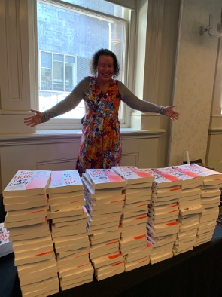

Carly Findlay, former Writeability Fellow, at her book launch in 2019. Photo by Writers Victoria.

# What is disability?

When we think a of a Disabled person, we often think of a wheelchair user. One in 5 Australians identify as d/Deaf and/or have disabilities. That may seem like a substantial number, but 80% of disabilities are not visible. Disability can be sensory, physical, cognitive, intellectual, developmental, Neurodiverse or Mental Health.

People with invisible disabilities often have their experience of disability questioned or disbelieved.

Disabled people are diverse and have intersecting identities; they are never just Disabled people. One million people from non-English speaking backgrounds are disabled in Australia[1]. Approximately 27% of the Aboriginal and Torres Strait Islander population, aged 15 years or older have a permanent or long-term health condition.

## Is disability a medical diagnosis?

No, not exactly. Historically, bodies have been categorised using the Medical Model of Disability as normal/abnormal, functioning/impaired, fixed/broken. Whereas, the Social Model of Disability makes an important distinction between impairment and disability.

* Impairment is the functional limitation within an individual.
* Disability is the loss or limitation to participation in everyday life due to social, attitudinal or environmental barriers.

This distinction between disability and impairment enables us to separate what is happening in the body or mind of a person and what barriers or attitudes are disabling them. Under the Social Model of Disability, disability becomes a form of oppression. It is an issue of access and human rights.

The degree to which a person is Disabled is directly impacted by the inaccessibility of the environment, communications and attitudes. This model recognises people’s full participation as citizens. We do not use the word disability to mean impairment. The word disability means barriers and discrimination. The problem is not the individual: everyone is involved in identifying and removing barriers.

The social model was developed by Disabled people. It is based on equality and human rights. It is used to identify and act against discrimination. It recognises that people are disabled by the barriers created by society, not by a medical condition or impairment.

## I don’t feel comfortable calling someone Disabled, isn’t it more polite to just say ‘person with disabilities’?

Disabled isn’t a bad word. We use the word Disabled as an act of pride and solidarity. The United Nations Convention on the Rights of Persons with Disabilities defines disability as an evolving concept that results from the interaction between a person with impairment(s) and any attitudinal or environmental barriers that hinder their full and equal participation in society. Defining disability in this way allows us to understand disability not as illness or capacity, but as matters of access and human rights. Using the term ‘Disabled’ or saying ‘I’m a d/Deaf and/or Disabled person’ is proclaiming belonging to a community and culture.

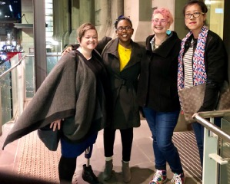

Meet me at the Intersection book launch 2018.

## Why have you used the phrase ‘d/Deaf and Disabled’? Aren’t deaf people Disabled?

We recognise and support the right of the Deaf community to not label their experiences as disability, but one of cultural and linguistic difference. Deaf people are not disabled by hearing loss but because sign languages are marginalised. Please refer to pages 30 and 31 for a more detailed discussion about ‘d/Deaf’ terms.

Extra resources

If you would like to learn more about the history of disability rights in Australia, USA and UK we recommend the following documentaries:

* Defiant Lives (ABC)
* Crip Camp (Netflix)

Or read the following article:

* [History of Disability Rights Movement in Australia](https://pwd.org.au/about-us/our-history/history-of-disability-rights-movement-in-Australia/)

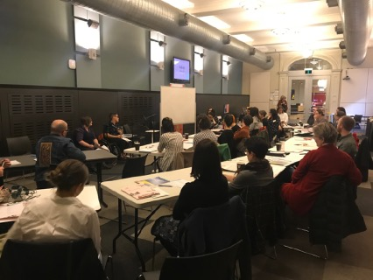

Publishability training, 2019. Photo by Writers Victoria.

## Activity: The Social Model of Disability

Please watch this [short video](https://pwd.org.au/resources/disability-info/social-model-of-disability/) about the social model of disability.

Watch this [short video commercial](https://www.youtube.com/watch?v=wzRQOfVvVh4&feature=youtu.be) about what the world would be like if we considered access.

Reflective questions:

* Have you encountered the Social Model of Disability before?
* What ways could you use this model in your work?
* Why might this model be considered useful in advancing human rights?
* How would the world be designed differently if it was designed with disability in mind?

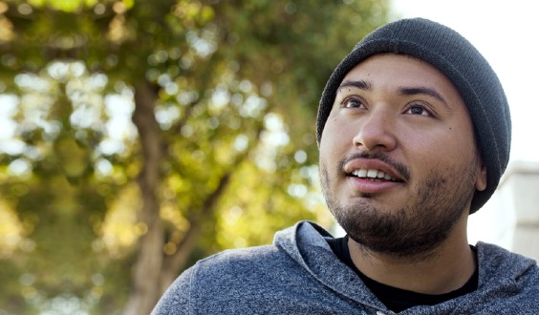

## Disability and the arts

There is a long and vibrant history of disability art.

Please refer to the resource guide at the end of the toolkit for disability-led arts organisations.

What does disability-led mean?

In an arts practice context, this means that d/Deaf and Disabled people have creative and decision-making control. In an organisational context, disability-led is defined by having a majority of d/Deaf and Disabled people in charge of the running and governance of the organisation.[2]

Barriers within the creative industries

The ‘2015 Survey of Disability, Ageing and Carers’ identified that among Australians with disability of working age, only 53% are participating in the workforce. This is a notable gap compared with the 83% participation rate of those with no reported disability. There is a larger proportion of people with disability engaging in part-time work; 56% of workers with disability are employed full-time, compared with 68% of those without disability. At the time of writing this toolkit we were not able to find any employment statistics on Disabled and d/Deaf people during the current Covid-19 pandemic, but it is likely that their unemployment rate has significantly increased.

Research shows that d/Deaf and Disabled people experience barriers entering and working within creative industries. In 2015, 9% of people in creative and cultural occupations reported having disability.[3] This is a significant underrepresentation in terms of the general population, with 18% of Australians reported having disability.

In 2009, the Victorian Government published the results of a community consultation about arts and disability in Victoria. The report[4] found:

“Negative attitudes to the arts in general, disability arts in particular or to disability itself, were all seen to function as active discouragements to participation both as audience members and artists”.

Getting in the door is not the only barrier to having a career in the arts. d/Deaf and Disabled creatives earn significantly less, with their gross incomes approximately 58% of their non‑Disabled colleagues.[5] And 90% of d/Deaf and Disabled artists[6] say that disability affects their practice. This may not be due to an individual’s impairments, but it could relate to the attitudes of people within an organisation. In 2015, 24% of d/Deaf and Disabled people who experienced discrimination said an employer was the source[7].

Reports of employment-related discrimination remain highest among young d/Deaf and Disabled people (aged 15 to 39 years). In this group[8], 36% of people who experienced discrimination reported an employer was a source and 20% reported work colleagues were a source.

The Australian Human Rights Commission’s Willing to Work report[9] states that “employment discrimination against people with disability is ongoing and systemic.” They concluded that:

“discrimination is underpinned by negative assumptions and attitudes that are held by many employers and throughout the community about the productivity and capability of people with disability.”

Neurodiverse or Disabled writers with intellectual or cognitive impairments face additional barriers when seeking to have their work considered for publication online or in print. When assessing an individual’s work one should not judge the writing skill, spelling or grammar mistakes to determine if the work is of value. These judgements are significant barriers for people with intellectual or cognitive impairments having their work taken seriously.

## How can you help break down the barriers?

In a study of the participation of d/Deaf and Disabled people in arts and cultural sector governance, it was reported that after accessible meeting venues, having co-workers undertake disability awareness training was the second most important factor in enabling participation.[10] According to the researcher, “a number of respondents referred to ineffective, inadequate, inconvenient, tokenistic or even hostile governance processes or procedures as the least positive aspect of their participation in governance”.

## How do I know if someone identifies with disability if 80% are invisible?

That’s true. Most disabilities are invisible and it’s the individual’s right whether they wish to disclose that they are d/Deaf and/or Disabled. So, it is best to ask everybody if they have any access requirements. This doesn’t mean asking someone about their symptoms or medical history, as that would be rude and invasive. But asking a question like: what do you need to do your job well? Do you have any access requirements? By asking everyone, it normalises the question and ensures that you don’t make any assumptions.

## Activity: Thinking about your workplace

Do you have any d/Deaf or Disabled people leading your organisation?

In the publishing industry are you aware of any d/Deaf or Disabled people in leadership roles?

We will revisit these questions later in this toolkit when we will provide you with some suggestions on how to measure diversity in your workplace and ways to increase it.

Extra resources

Read [Fiona Murphy’s award-winning article](https://overland.org.au/previous-issues/issue-237/fair-australia-prize-essay/) on her reticence to disclose her Deaf identity in the workplace.

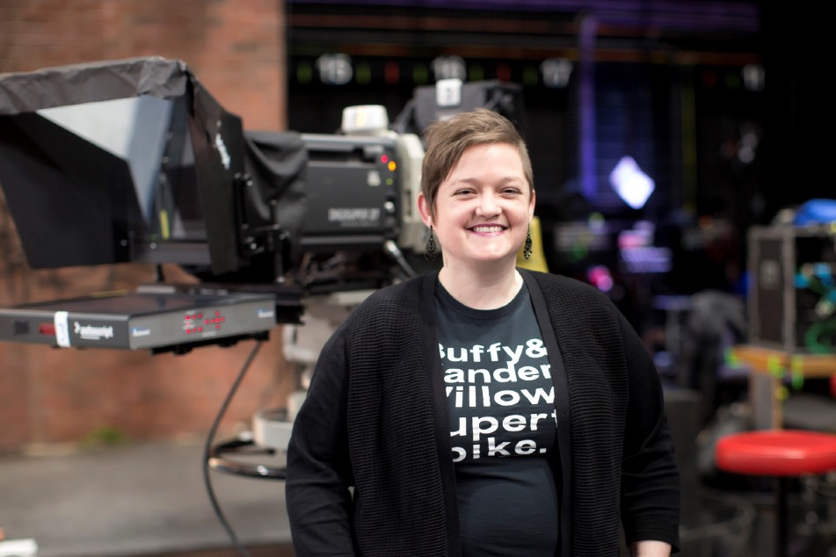

Jessica Walton, former Publishability Fellow. Image supplied.

# Finding d/Deaf and Disabled writers

In this section we will explore where you might find d/Deaf and Disabled writers, and the value and power of #OwnVoices writing.

## What is ‘Own Voices’?

In 2014, the grassroots campaign ‘We Need Diverse Books’ started. It focused on increasing the number of Disabled characters in Kid’s Lit.

The following year, YA author and co-founder of Disability in KidLit, Corinne Duyvis, created the hashtag #OwnVoices. This took the conversation beyond just wanting to have diverse characters in books, to highlighting the diversity of the authors behind the books.

Own Voices tells the stories of disability with the nuance and value of lived experience. All too often d/Deaf and Disabled stories are told by non-Disabled people. As a consequence they frequently contain stereotypes or assumptions about the experience of disability. Own Voices work seeks to redress this imbalance and provide space to those stories told by marginalised people.

“Those books that are #OwnVoices have an added richness to them precisely because the author shares an identity with the character. The author has the deepest possible understanding of the intricacies, the joys, the difficulties, the pride, the frustration, and every other possible facet of that particular life — because the author has actually lived it.” – Kayla Whaley, novelist and essayist

Following #OwnVoices on social media is a good way to connect and stay up to date with what is happening in the #OwnVoices space.

## Activity: Where are all the d/Deaf and Disabled writers?

Next, lets read ‘[Where are all the disabled writers?](https://sydneyreviewofbooks.com/review/cambridge-companion-to-literature-and-disability/)’ by Amanda Tink

How often have you encountered ‘narrative prosthesis’ in literature?

## Activity: The Fries Test

Modelled off the Bechdel test for the representation of women in movies, the Fries Test asks the following questions:

1. Does a work have more than one disabled character?
2. Do the disabled characters have their own narrative purpose other than the education and profit of a non-disabled character?
3. Is the character’s disability not eradicated either by curing or killing?

Passing the test requires a yes to all three.

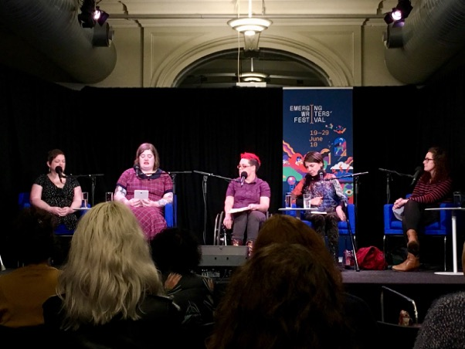

## Intersectionality

Intersectionality is a theory by Kimberlé Crenshaw that individuals have many different aspects which make up who they are such as race, class, gender identity or disability. These aspects or identities intersect or overlap creating a matrix of disadvantages and privileges in an individual’s experience. Crenshaw first used it to explore how African American women experience both sexism and racism in their lives, but it is now also used to explore other aspects of social disadvantage. To quote Crenshaw: ‘’Intersectionality is a lens through which you can see where power comes and collides, where it interlocks and intersects.”

‘’All bodies are unique and essential; All bodies have strengths and needs that must be met; We are powerful, not despite the complexities of our bodies, but because of them; All bodies are confined by ability, race, gender, sexuality, class, nation state, religion, and more, and we cannot separate them.’’ – Patty Berne, Co-Founder, Executive and Artistic Director, Sins Invalid

Disability can also be understood through an intersectional lens. Viewing disability or Deafness in this way enables us to see it as an important aspect of a person’s identity, both politically and personally, and shapes their experience of the world and interactions with Ableism.

## What is ableism?

Ableism is discrimination in favour of able-bodied/non-Disabled people. Ableism characterises persons as defined by their impairments and as inferior to non-Disabled people.

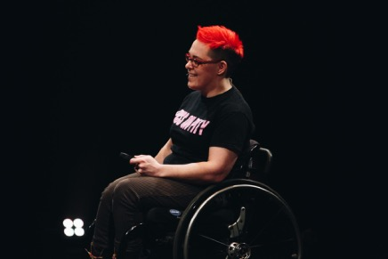

Former Publishability Officer, Jax Jacki Brown, performing at the Campbelltown Arts Centre, 2018. Photo by Catherine McElhone.

## Activity: Finding d/Deaf and Disabled writers

Scenario

You are open to the idea of working with writers with disability, but no one seems to approach your company asking to work with you.

One of your goals is to have greater representation of people with disability in the books you publish.

* How can you actively encourage people with disability to become involved?
* How and where do you ‘find’ d/Deaf and Disabled people?
* How will you promote the opportunities?
* What language will you use?

## Where to find d/Deaf and Disabled writers?

The best way to find d/Deaf and Disabled writers is to connect with the community. This can include:

* making contact with disability arts organisations and letting them know you are interested in #OwnVoices work
* following up on the list of disability arts organisations provided at the end of this toolkit
* contacting Writers Centres and local Arts Centres
* following disability hashtags
* subscribing to disability media, such as the People with Disability Australia newsletter
* keeping note of who is winning writing prizes, including the Dulcie Stone Writers Competition.

Again, the list below is not exhaustive and should only be taken as a guide. We welcome your suggestions and additions. This list was published January 2021.[11]

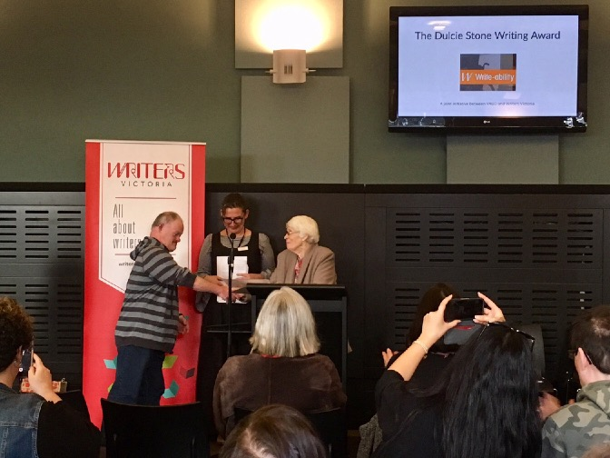

Dulcie Stone Awards.

Twitter

* [Damian Griffis](https://twitter.com/dameadvocate)
* [El Gibbs](https://twitter.com/bluntshovels)
* [Carly Findlay](https://twitter.com/carlyfindlay)
* [Jessica Walton](https://twitter.com/JessHealyWalton)
* [Fi Murphy](https://twitter.com/fi_murphy_)
* [Heidi Everett](https://twitter.com/_HeidiEverett)
* [Ellen Fraser-Barbour](https://twitter.com/ellenffb)
* [Senator Jordon Steele-John](https://twitter.com/Jordonsteele)
* [Alice Wong](https://twitter.com/SFdirewolf)
* [Scott Avery](https://twitter.com/ScottTheHolWrld)
* [Geoff Trappett OAM](https://twitter.com/InclusionMoves)
* [Rosemary Kayess](https://twitter.com/RosemaryKayess)
* [Robin M Eames](https://twitter.com/robinmarceline)
* [CB Mako](https://twitter.com/cubbieberry)
* [Ricky Buchanan](https://twitter.com/jeshyr)

Hashtags to follow

#OwnVoices

#NothingAboutUsWithoutUs

#DisabilityVisibility

#DisabilityJustice

#DisabilityRC

#InvisibleIllness

#ChronicLife

#spoonie

#DeafTalent

#ActuallyAutistic

#babewithamobilityaid

#DisabilityPride

Instagram

@thesineadburke

@sitting_pretty

@caryfindlay

@_astridedwards_

@crutches_and_spice

@disability_visibility

@eddiendopu

@deafferent

@expressionaustralia

Disability organisations

* [National Ethnic Disability Alliance (NEDA)](http://www.neda.org.au)
* [First Peoples Disability Network (FPDN)](https://fpdn.org.au)
* [Women With Disabilities Australia (WWDA)](https://wwda.org.au)
* [People With Disability Australia (PWDA)](https://pwd.org.au)

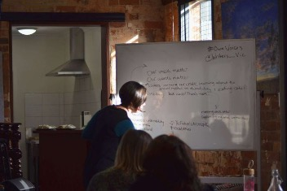

# Working with d/Deaf and Disabled writers

If you’ve never worked with a d/Deaf and/or Disabled writer, the best thing to remember is that it’s like any working relationship. There should be an equal understanding of roles, expectations and deadlines.

“Yet even talking about disability can be a fraught experience. The vocabulary of this status is highly charged, and for even the most well-meaning person, a conversation can feel like stepping into a maze of courtesy, correctness and possible offense. When I lecture about disability, someone always wants to know — either defensively, earnestly or cluelessly — the “’correct’ way to refer to this new politicized identity … As we manage our bodies in environments not built for them, the social barriers can sometimes be more awkward than the physical ones. Confused responses to racial or gender categories can provoke the question ‘What are you?’ Whereas disability interrogations are ‘What’s wrong with you?’” – Rosemarie Garland-Thomson, ‘Becoming Disabled’, The New York Times

Instead of guessing how someone wishes to be identified or what their access requirements may be, it is better to ask.

## Activity: Asking about access

In your role you are keen to find out about a d/Deaf and/or Disabled person’s impairments to better understand their access requirements and know what to expect.

* How do you do this?
* Is it reasonable to expect someone to disclose information?
* Who can you go to and where do you find access information and resources?
* How would you approach this with the person? What language would you use?

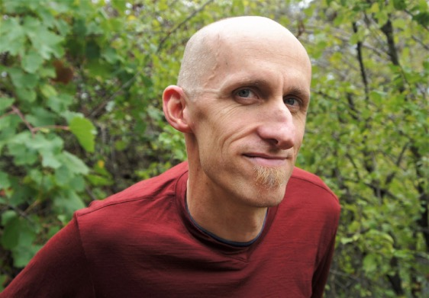

Andy Jackson, poet and former Write-ability mentor. Image supplied.

## Language and disability

Language in the Disability and Deaf community, like in other minority groups, is personal as well as political. It’s evolving and changing, challenged and contested. Some people like to use person-first language, ‘person with disability’. Some like to use identity first language, ‘Disabled person’. Others might like to use the name of their medical condition/s, whereas another person may feel very uncomfortable disclosing this type of information. As within any minority group, the language individuals choose to use and identify with is their choice and should be respected. It is best to not assume how a person might identify but to wait for them to tell you who they are and what labels or language holds meaning for them.

Extra resources

Read the following article and reflect how it highlights the personal, political and contested debate on Disabled vs person with disability language.

‘[Why I’m Reclaiming the Word Disabled](http://www.dailylife.com.au/news-and-views/dl-opinion/saytheword-why-im-reclaiming-the-word-disabled-20160120-gma4uj.html)’ by Jax Jacki Brown

‘[What is ableist language and what’s the impact of using it?](https://pwd.org.au/resources/disability-info/language-guide/ableist-language/)’ by People with Disabilities Australia

The most important thing is to listen to the d/Deaf and Disabled person that you are working with and respect and understand their preferences. Understanding how words have been used and continue to be used as derogatory in relation to disability can provide us with new perspectives and awareness when working with d/Deaf and Disabled writers.

“People with disability are often described in ways that are disempowering, discriminatory, degrading and offensive… People with disability want our lives to be respected and affirmed. Many people with disability are proud of being disabled, and want that identity respected.” – People with Disability Australia

The following section is a guide on language and disability by Arts Access Victoria, published in January 2021.

The language of disability is always evolving, and different terms are used within and outside of Australia. Here are a few tips to help you on your way.

## Important things to remember

* Avoid stereotypical or stigmatising depictions of d/Deaf and Disabled people
* Avoid phrases and words that demean d/Deaf and Disabled individuals
* d/Deaf and Disabled people are not ‘suffering from’, ‘victims of’ or ‘afflicted by’ their impairments
* d/Deaf and Disabled people are not overcoming their disability, but the barriers that the rest of society puts in front of them
* d/Deaf and Disabled people should not be portrayed as courageous or tortured, but rather as individuals who find alternative means to accomplish everyday activities

## When should I capitalise Deaf?

A capital D is used to indicate that the subject or audience identifies with Deaf culture. Lowercase ‘d’ is used when speaking about a person’s physical condition of hearing loss.

When writing about topics around Deaf culture—such as sign language, community and art—use ‘Deaf’. The term ‘hearing impaired’ should never be used as it is incredibly offensive. Deaf people do not consider themselves to be ‘impaired’, but they are a linguistic minority who experience isolation and exclusion due to the oppression of sign language. Deaf people may feel a sense of ‘Deaf Gain’—they have not ‘lost’ their hearing, but have gained culture, community and language.

Not all people with hearing loss identify as ‘d/Deaf’; many people choose to identify as ‘hard of hearing’. Therefore, to ensure that you are inclusive to all identities it is advised that you use the phrase ‘d/Deaf and hard of hearing’ (DHH) when generally referring to people with hearing loss.

Additionally, you will have noticed that we are using the term ‘Disabled’ throughout this toolkit. We are doing so deliberately as using Disabled with a capital refers to Disability pride, Disability culture and Disability identity.

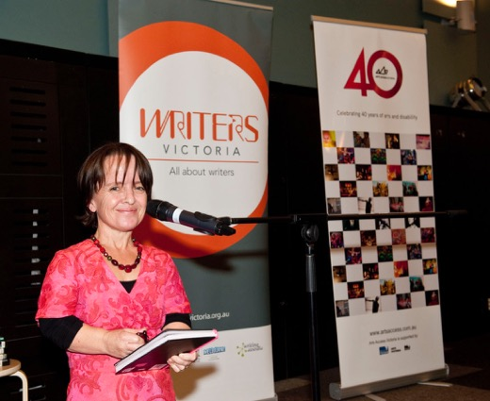

Writeability Salon artist Leisa Prowd presenting at the Emerging Writers Festival in 2014. Photo by Paul Dunn.

# Language do’s and don’ts

| Words we recommend | Words we don’t recommend |
| --- | --- |
| Deaf and Disabled people/person | The disabled  People/person with a disability  People/person with disabilities  Differently abled/diffability  Handicapped  Invalid  Physically challenged  Special needs |
| Non-disabled people/person | People/person without disability  Able-bodied  Normal |
| Wheelchair user | Wheelchair bound  Bound/confined to a wheelchair |
| Blind  Vision impaired  Low vision | The Blind  Visually impaired  Person without sight |
| Deaf people/person  Auslan user  Hard of hearing | The Deaf  Deaf and dumb  Deaf and mute  Hearing impaired |
| Learning disabled  Learning disability  Intellectual disability | Retard/ed  Slow learner |
| Person of short stature | Midget  Dwarf |
| Mental health issues | Mental health problems  Mental  Mental illness  Mentally ill |
| Accessible toilet | Disabled toilet |
| Accessible parking | Disabled parking |
| Has  With a lived experience of | Suffers from  Afflicted with  Victim of |
| Do you have any access requirements? | Do you have a disability? |
| Inclusive (except where ‘inclusive’ is used to mean ‘disability-only’) | All-abilities  Integrated |
| Support worker  Personal Assistant | Carer  Companion |
| They/them  He/she (where someone has told us their pronouns)  Non-gender specific terms (waiter, actor, etc) | He/she (where someone hasn’t told us their pronouns)  Gender-specific terms (waitress, actress, etc) |

## Additional resources

While you may refer to the following style manuals when editing, we strongly recommend that when working with d/Deaf or Disabled authors you confirm the individual preferences of the author themselves.

* [Australian Government Style Manual](https://www.stylemanual.gov.au/format-writing-and-structure/inclusive-language/people-disability)
* Australian Manual of Style Coming out soon! Developed by a consortium in association with Macquarie University

The language we use regarding disability is not only relevant when editing the work of d/Deaf and Disabled writers but is also something we need to be aware of when editing all writing. Language holds power. Disability slurs perpetuate harmful stereotypes. Challenging outdated or offensive terms― as well as changing the types of terms we deem acceptable in literature― plays an important role in changing society through changing attitudes. As editors and publishers, you are in a very significant position to drive this cultural change. You can do this by having discussions on the page, in the margins, as you edit work about the power of language in shaping how we think and by extension how we write about and perceive disability.

Ableism is everywhere. It creeps into our everyday vernacular without us even noticing. Beginning to notice it in ourselves and others and choosing not to use it is the first step to change.

Listen to the following [podcast](https://guiltyfeminist.libsyn.com/podcast/107-language-with-carly-findlay-and-rana-hussain) interview and reflect how it highlights the impact and prevalence of disability slurs.

d/Deaf and Disabled people are often described in language that places their lived experience on either end of a limited spectrum: they’re either inspirational or deserving of sympathy. Some common negative clichés include:

* She didn’t let disability stop her
* Brave, inspirational or courageous
* …will never again see their children’s faces/run a marathon
* Confined to a wheelchair
* Refused to give up/give in
* Suffers from
* Sub-human or super-human
* Normal vs abnormal
* Tragic, sad or a burden
* Brave soldiers suffering in adversity
* Deserving of pity
* Helping them makes me a better person

The reality is that d/Deaf and Disabled people are as multidimensional and multitalented as Non-Disabled people. They are our customers, leaders, colleagues, experts, vendors and valued members of our society.

## Activity: Avoiding inspiration porn

Watch Stella Young’s TEDx Talk below

[I’m not your inspiration, thank you very much](https://www.ted.com/talks/stella_young_i_m_not_your_inspiration_thank_you_very_much?language=en)

Reflective questions:

Can you recall any inspiring memes or stories about disability?

What, according to Stella, is the lie about disability we have all been sold?

What does she view as the problem with inspiration porn?

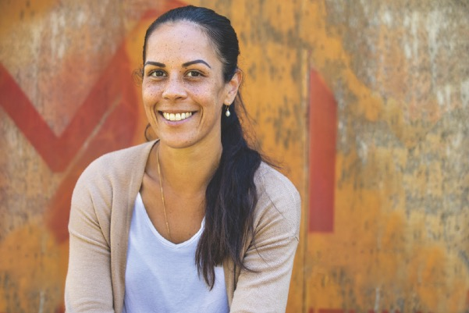

# Promoting d/Deaf and Disabled writers

A publishing house needs a coordinated approach across its departments. This is a crucial aspect of ensuring that the representation of d/Deaf and Disabled writers is appropriate, considered and consistent.

Things to consider include:

* Briefing teams (marketing, publicity, sales, design, etc.) when the book is acquired. Briefing them throughout essential stages of the project. Briefings should includekey areas such as preferred and best-practice language;
* Clarification early-on and throughout the project about the POV and angle the story will take. i.e. avoiding ‘overcoming adversity’ or ‘tragic’ marketing and sales language;
* Close consultation between publicity, marketing, design, sales and the editor and/or author on how the book is being pitched to booksellers. Awareness of the types of language and graphics used in advertising;
* Continued consultation between departments about metadata. Sending out incorrect or inappropriate data early on in the process can have long-lasting consequences. The language used in descriptions here is vital to the representation and perception of the author and book;
* Bringing the author into discussions across departments to allow for consultation. Noting that their lived experience of disability is central. This experience should guide how the publisher approaches and markets the book;
* Upholding a positive and open learning environment. Teaching and encouraging staff to develop their understanding of preferred and best-practice language and the Social Model of Disability;
* Creating information sheets for sales, booksellers and potential media. This sheet should guide them in the use of language, framing of the story, how the book is being marketed. It should specify what the book is not. For example, comparing the book to other titles that negatively portray disability. Unless indicated by the author, not selling the book as motivational/inspirational. Unless indicated by the author, not selling the book as an example of overcoming adversity.[12]

## Accessible social media

You can make social media posts accessible by:

* Including image descriptions
* Avoiding using a mix of fonts or all-caps in Tweets – this makes it difficult for people who use screen readers
* Capitalising each word of a hashtag, for example #OwnVoices instead of #ownvoices
* Including captions for any videos of any length (including IG stories, TikToks, YouTube videos)

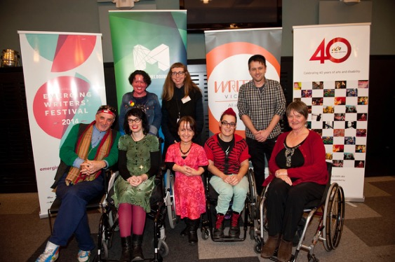

Write-ability salon artists at the 2014 Emerging Writers Festival. Photo by Paul Dunn.

## Activity: Creating an author bio

Read the author bio and answer the questions below

Author bio

Jessica Walton was a beautiful young girl with a promising future and a dream of becoming a dancer, until a devastating diagnosis at the age of nine changed everything. The bone tumour growing inside her left leg was a tragedy, but with the love of her family and the support of her doctors, little Jessica bravely faced her disease, and won.

While Jessica’s left leg had to be amputated above the knee, her parents made sure she grew up knowing that the only real disability in life is a bad attitude. Each day, Jessica put on her prosthetic leg and showed the world that while she was missing a leg, she wasn’t really missing out on anything – she could overcome her disability and face any challenge life threw at her, and she could inspire the people around her at the same time.

This book will make you laugh, make you cry, and make you marvel at the extraordinary strength of the human spirit. Jessica’s sheer determination to get back on her feet and jump back into life will amaze you. Even when Jessica developed chronic pain as an adult, her horror at the unfolding opiate crisis inspired her to throw away her drugs and fight through the pain.

Jessica’s story will provide readers with a whole new outlook on life and motivate them to go after their dreams. After all, if Jessica can beat cancer and live life to the fullest with one leg and unmedicated chronic pain – what’s your excuse?

* What kind of language can you identify in the above example?
* Which language perpetuates stereotypes of d/Disabled people?
* How would you re-word this, using best-practice language?
* Reflecting on this exercise, how confident do you feel identifying and editing problematic language or stereotypes?

## Activity: Examples of good access information pages

Look at the pages below which outline the types of access provided by these two festivals. Note the different kinds of access they have listed.

* [The Melbourne Fringe Festival](http://melbournefringe.com.au/access)
* [Midsumma Festival](https://www.midsumma.org.au/info/access-information-2020/)

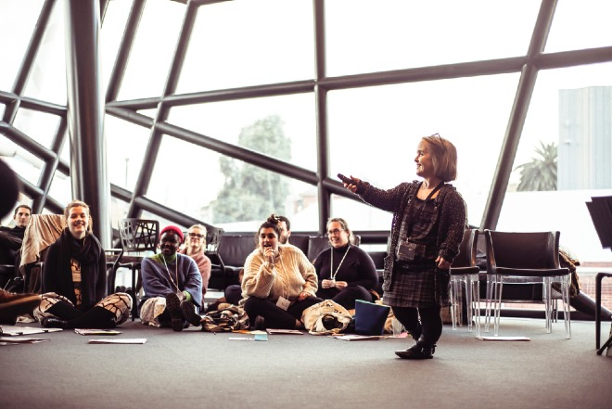

Arts Access Victoria training. Image supplied.

# Creating an inclusive organisation

## Individual attitudes and behaviours

“The opposite of disability is not ‘ability’, it is access…” – Fiona Tuomy, Director, The Other Film Festival

Understanding both the Social and Human Rights Models of Disability means that disability is no longer defined as a medical problem or deficiency that is up to the individual to manage. Disability is the term used to name the discrimination, barriers to opportunity, marginalisation and oppression that people experience in society. Most importantly, by recognising that disability is a construct of inequity maintained in our society, we can recognise that it is changeable, and that we must all work together to change our society, our workplace, and our individual practice.

Actively removing these barriers to opportunity and building bridges to create meaningful inclusion in your organisation is simply a matter of individual attitudes and behaviours. This is often referred to as searching for ‘Social Model Solutions’ or providing access and collaborative consultation instead of making assumptions or decisions on behalf of someone else. [For more examples see the Australian Federation of Disability Organisations](https://www.afdo.org.au/social-model-of-disability/).

Here are some suggestions to ensure your attitudes and behaviours promote inclusion when working alongside d/Deaf and Disabled colleagues, writers, and creatives.

Are you:

* Asking the right questions to prioritise access and remove barriers:
  + What are your access requirements?
  + What do you need to do your best work?
  + What opportunities for reciprocal learning are there?
* [For more information on Access Statements see Little Cog](https://www.littlecog.co.uk/artist-access-statements.html).
* Avoid prerequisite thinking, limiting assumptions and low expectations:
  + ‘You need to be X, X and X to do this job…’
  + ‘I’m sure they won’t be able to…’
  + ‘I’d better do this for them…’
* Using innovation, breakthrough thinking, consultation and creative problem-solving to develop solutions to barriers:
  + What can we do to make this possible?
  + [Follow this link for 25 suggestions on how to foster breakthrough thinking](http://www.ideachampions.com/25_ways.shtml)

Being aware of the barriers in society (i.e. environmental, attitudinal, socioeconomic, and communication barriers) and finding solutions without analysing their root cause could mean we fall into a cycle of problem-solving, gatekeeping and reacting to case-by-case issues of exclusion and lack of access.

“Helping get more disabled people in these positions of power will take a cultural shift, but there are also simple practical measures that will help – from ensuring internships at publishers are paid, to offering remote or flexible working, to putting out job ads that explicitly ask for disabled applicants.” – Frances Ryan, ‘Publishing must make room for disabled authors — for its own good’, The Guardian, 5th September 2020

We can work together to remove discrimination and dismantle the barriers to choice and opportunity. We can do this by questioning why certain barriers are maintained in our society and acting on change. For example:

You have an initial meeting with a writer who is a wheelchair user. When they arrive at your workplace, you organise for a temporary ramp to be laid out to cover the steep flight of stairs to the entry. This removes the physical barrier to the building on that single occasion. However, such a temporary solution does not provide your premises step-free access for future drop-ins, new/unknown talent, or potential employees of your organisation to enter without first making an appointment and relying on another person to lay out the ramp. Most importantly, it sends an unspoken message of unwelcome to many and does not position your organisation as accessible or inclusive. Replacing the steps with a permanent ramp permanently removes this barrier. But in order to make this change a ramp must be purchased by your organisation, and in order to achieve this, the real barrier to overcome is the lack of priority for access in the budget. What funding could you find from within your company/other organisations to pay for the renovation? How can you find a proactive solution to this issue?

Before taking on larger systematic changes, the best place to start is by recognising our own explicit and implicit biases towards d/Deaf and Disabled people and taking action to combat ableism on a personal level. There is so much that can be changed by [recognising microaggressions and offering micro-affirmations](https://www.brown.edu/sheridan/microaggressions-and-micro-affirmations-0).

“If you think you are too small to make a difference, try sleeping with a mosquito [in the room]” – The Dalai Lama

## Personal action plan

“Ally means partner. Ally is an action, an alliance you build, not something you identify as.” – Kochava Lilit, queer disabled activist

In order to build an alliance with the disability community, a personal action plan will help you to map out your journey to create meaningful change.

When making your personal action plan, it may help to use [this template](https://creately.com/blog/diagrams/how-to-write-an-action-plan/) and to ask yourself these questions:

* What is one thing you can personally achieve?
* When can you reasonably make this change?
  + An achievable timeframe may be within the next 12 months.
* What is getting in the way?
  + Identify the barriers – are these e.g. attitudinal?
  + What is the ‘Social Model Solution’?
  + What access is needed?
* Who is involved?
  + How can you engage with others?
  + This is your personal action plan – it can be in your workplace or with friends or family
  + Arts Access Victoria and Writers Victoria are available to help and consult with you

Here are some suggestions for achievable change that you may wish to use as a personal action plan:

* Put access on the agenda at every staff meeting
* Set affirmative employment opportunities in your organisation
* Introduce flexible working arrangements/hours
* Change your workplace culture! Find three people in your organisation and talk to them about how your organisation engages with disability
* Commit to publishing quotas of d/Deaf and Disabled writers in the next 12 months
* Ensure that all digital communication is accessible and ALT text and image descriptions are used
* Ask the writer you are currently working with, “What do you need?” and start the conversation about access

## Employment

“No matter how diverse we are, without inclusion we remain separated by physical, social, cultural and emotional barriers, and the creative spark is quenched by sameness and groupthink.” – Professor Ian Harper, Dean of Melbourne Business School, Reserve Bank Board Member, former Chair of the Competition Policy Review.

Watch this short video on Diversity and Disability:

[Diversity: we’ve got this nailed, right? Wait a minute… Didn’t we just forget 1.3 billion disabled people?](https://www.youtube.com/watch?v=p7Gp6_LPmXc)

Many corporate discussions around ‘diversity’ are only beginning to include disability. Yet we know that 18% of the population identify with Disability. We know that more than 80% of impairments are invisible. Do you really know the disability status of your organisation? Is this information being collected? More often than not, it isn’t.

The first step is to look at who is already inside your organisation. Take take stock to find out who already has a seat at the table. This way we can then begin to ask ourselves, who is missing? And why?

There are a range of barriers to measuring the disability status of current employees within your organisation. These must be addressed to make meaningful change and create a reputation as a leader in your industry for access and inclusion. An individual’s personal choice to disclose their experience of disability is often fraught with identity politics, stigma, fear of discrimination and internalised ableism, or simply a hesitation that this information will be used inappropriately. Are there systems in place to respectfully collect this information and keep it confidential?

The benefits to conducting [a successful diversity survey](https://www.dca.org.au/research/project/di-101-conducting-diversity-survey) and identifying the current disability status of your employees include implementing appropriate workplace adjustments and driving more qualified decisions about your future work. But most importantly, it allows you to establish an accurate baseline for employment targets to monitor your progress against.

## Targets

Setting achievable employment targets and taking affirmative action on disability is not a ‘one-size-fits-all’ approach. But it does involve setting an overarching goal to build and maintain an inclusive workplace culture, and a commitment to prioritising inclusion as part of every process.

In order to set targets and define what success looks and feels like, it may help to break down your vision into strategic goals, which can be measured against key deliverables, with hard deadlines.

For example, you may start by identifying your vision:

* To build a reputation for your organisation as an inclusive employer for d/Deaf and Disabled people

Next, breaking that into strategic goals may include creating specific goals, such as:

* Create pathways for d/Deaf and Disabled writers to engage with our organisation
* Increase employment of d/Deaf and Disabled people
* Share our successes with the industry

Turning these into key deliverables may look something like this:

* Joining forces to create external partnerships with a number of other organisations/representatives of communities to reach out to formally engage with a number of d/Deaf and Disabled writers/creatives.
* Commit to employing a comparable percentage of d/Deaf and Disabled people within our organisation, (e.g. 18% – this may be three to four people in a 20-person organisation) through guaranteeing interviews to any d/Deaf and Disabled person who meets the requirements of the position
* Commit to external benchmarking (see [AND’s Access and Inclusion Index](https://www.and.org.au/pages/access-inclusion-index.html)) to monitor your progress and sharing these challenges/successes with other organisations and individuals in our sector and encourage them to do the same
* Set up an action-focused disability working group to drive change within our sector
* Co-design and publish an Access Statement on your website (here is an example of [a detailed accessibility policy](https://www.passervulpes.com/accessibility-policy))

Finally, operationalise these by assigning each deliverable to key people within your organisation and setting hard deadlines. This means that your vision becomes a reality, and not just an aspiration. E.g.:

| Deliverable | Deadline | Assigned To |
| --- | --- | --- |
| 18% of employees identify as d/Deaf and/or Disabled | December 2022 | HR, Name Name, Name Name |
| A network of allies committed to access and inclusion in the publishing industry | June 2021 | Name Name, Department, Name Name |
| Quote number of d/Deaf and Disabled writers published | June 2022 | Name Name, Name Name, Name Name, Name Name, Name Name |
| An active disability-led working group | August 2021 | HR, Name Name, Name Name |

Here is a good example of a public [Diversity and Inclusion Plan](https://about.abc.net.au/wp-content/uploads/2019/11/ABC-Diversity-Inclusion-Plan-201922.pdf) which follows this format.

Setting targets like the ones above within your organisation will make meaningful change and allow stories that resonate with everyone to be shared.

# Useful services and organisations

Below is a list of organisations that offer a range of services and support across disability, mental health and the Deaf community.

Arts Access Australia

[Arts Access Australia](https://artsaccessaustralia.org) (AAA) is the national peak body for arts and disability in Australia. AAA works to increase national and international opportunities and access to the arts for people with disability as artists, arts-workers, participants and audiences.

Victoria

[Arts Access Victoria](https://www.artsaccess.com.au) (AAV) is a [disability-led](https://www.artsaccess.com.au/about/our-language/) arts organisation. AAV is at the forefront of innovative disability arts practice, access and inclusion. AAV works with artists at all levels of their careers to develop their practice and influence in the arts sector. AAV works with organisations big and small at all levels, from consulting on access to partnerships that increase disability arts and Deaf and Disabled artists with in the organisations.

[Writers Victoria](https://writersvictoria.org.au) supports and connects all types of writers at all stages of their writing careers by providing courses and workshops, magazine, mentorships or manuscript assessments. The Write-ability program provides mentorship to five d/Deaf or disabled writers a year.

Western Australia

[DADAA](https://www.dadaa.org.au) is a not-for-profit community arts and cultural development (CACD) organisation, focusing on creating significant positive social change and opportunities for Deaf and Disabled people or people with mental health issues. Based in Fremantle, WA.

NSW and ACT

[Accessible Arts](https://aarts.net.au) is the peak arts and disability organisation across New South Wales and the ACT.

Queensland

[Access Arts](http://accessarts.org.au) is Queensland’s peak body working with artists, cultural workers and their communities.

Northern Territory

[Arts Access Darwin](https://aarts.net.au) works in the greater Darwin area to improve access to the arts for people with disabilities.

South Australia

[Access2Arts](https://access2arts.org.au) works across all art forms to increase access and support the professional development of d/Deaf and Disabled artists in South Australia.

Central Australia

[Incite Arts](http://incitearts.org.au) delivers high-quality, accessible arts programs in collaboration with the communities of Central Australia, focusing on both those who are under-served and those who face barriers to arts engagement.

# Services for people who are blind or have low vision

Audio description equipment

[Word of Mouth](http://www.wom.com.au) (purchase or hire)

03 9723 0660

Audio description services

Description Victoria

[Description Victoria](http://www.descriptionvictoria.com.au) provides professional audio description for live events and media such as film and video.

0405 725 423

Red Bee Media

[Red Bee Media](http://www.redbeemedia.com.au)

03 9696 1996

AI Media

Ai Media provides captions, transcripts, subtitles, described video and more.

Vision Australia

Offers a service staffed by volunteers. It is a free service run from their Sydney office. Check the Vision Australia audio described [events calendar](http://www.visionaustralia.org/about-us/events).

Contact [Michael Ward](mailto:Michael.Ward%40visionaustralia.org?subject=)

The Captioning Studio

[The Captioning Studio](http://www.captioningstudio.com/audio-description/) provides audio description for film and video.

Guidelines for print size, type and format

For hard copy and online information the [Print Disability](http://printdisability.org/guidelines) website provides a set of guidelines to follow.

Accessible Documents

Are all of your digital documents accessible for people who use screen readers from your internal documents to everything that goes out to the public?

[Tagged PDF](http://taggedpdf.com.au) works with companies to ensure all of their documents are accessible.

Braille

[Vision Australia](http://www.visionaustralia.org/business-and-professionals/print-accessibility-services/alternate-format-production) provides a Braille translation service.

03 9864 9602

Hearing loops (purchase)

Contact [Word of Mouth](http://www.wom.com.au/hearing/hearing-augmentation/loops) for general queries. If you already have a hearing loop or wish to discuss what may be suitable for your venue, Word of Mouth also provides this service.

03 9723 0660

# Services for people who are d/Deaf or hard of hearing

National Relay Service

The [NRS](http://www.relayservice.gov.au) is an Australia-wide phone service for people who are deaf or have a hearing or speech impairment. The NRS is available to everyone at no additional charge, 24 hours a day, anywhere in Australia. All calls are confidential. There are a variety of relay methods that can be used, e.g. internet, captioned, SMS, video, type and read, speak and read, type and listen, speak and listen.

Expression Australia

[Expression Australia](http://www.expression.com.au) is a not-for-profit organisation that provides information, programs and education to over 16,000 d/Deaf and hard of hearing adults each year through its diverse range of services across Victoria, with the aim of achieving access and equity for d/Deaf and hard of hearing people.

Auslan Interpreters

For meetings, discussions, forums, workshops, talks or in the workplace, networking or social gatherings. The following both provide qualified professional interpreters.

Auslan Connections

[Auslan Services](http://www.auslanservices.com)

Auslan Interpreters for creative purposes

For example, film, theatre, video, advertising.

[Auslan Stage Left](http://www.auslanstageleft.com.au) is highly regarded by the Auslan community.

Captions

[The Captioning Studio](http://www.captioningstudio.com)

08 8463 1639

[Red Bee Media](http://www.redbeemedia.com.au)

03 9696 1996

Signbank

[Auslan Signbank](http://www.auslan.org.au) is a language resources site for Auslan (Australian Sign Language), providing a dictionary where the user can search for signs related to medical, health and educational topics.

# Other organisations and services

Employment Assistance Fund (EAF)

The Australian Government’s [Employment Assistance Fund](http://www.jobaccess.gov.au/downloads/employment-assistance-fund-guidelines) (EAF) provides financial assistance to a person with disability or their Employer for workplace modifications, equipment and services they require as a result of their disability and are necessary for them to be able to perform their Employment duties.

The objective of the EAF is to encourage and support the Employment of people with disability, improve their access to work opportunities, and maximise their capacity and workplace independence.

ERMHA

The [ERMHA](http://www.ermha.org) works with people with a lived experience of mental illness or cognitive disability who have fallen through the cracks in the system to ensure that they and their carers can thrive in the community they live in.

Schizy Inc

[Schizy Inc](http://www.schizy.org/about.html) makes space in the arts for people with schizophrenia and diverse experience of mental health.

SANE

[SANE Australia](http://www.sane.org) is a national mental health charity working to support four million Australians affected by complex mental illness. SANE’s work includes mental health awareness, online peer support and information, stigma reduction, specialist helpline support, research and advocacy.

Brain Injury Matters

[Brain Injury Matters](http://www.braininjurymatters.org) Inc (BIM) facilitates self-advocacy and community education for people living with an [Acquired Brain Injury](https://www.betterhealth.vic.gov.au/?OpenDocument).

Valid

[Valid](http://www.valid.org.au) provides a range of advocacy and information strategies that connect together, supporting people with disability towards empowerment, inclusion and lives in their community.

# Marketing and communications

* Accessible website features and standards from Media Access:
  + [Accessible Website Design](https://web.archive.org/web/20200414181424/http://www.mediaaccess.org.au/digitalaccessibilityservices/accessible-website-design-optimal-usability/)
  + [Standards](http://www.w3.org/standards)
* Accessibility for people with vision impairment ([Vision Australia](http://www.visionaustralia.org/business-and-professionals/print-accessibility-services))
* Example of an accessible website ([Arts Access Victoria](http://www.artsaccess.com.au))
* [Access Symbols](http://www.artsaccess.com.au/universal-access-symbols). Information on why and how to use with access symbols and information
* Access in digital technology. Website Content Accessibility Guidelines created by the W3C. [These are the global access standards for all websites](https://www.w3.org/WAI/standards-guidelines/wcag/).

The Federal Government set up The Digital Service Standard (DSS) in 2014 for Australia access standards online.

* Access features in commonly used programs and technology ([Affordable Access](http://www.affordableaccess.com.au))[13]

# Disability literature websites

## Disability in Kidlit

[Reviews](http://www.disabilityinkidlit.com) of books about disability, by Disabled people who share that disability.

## Disability Literature Resources List

[Disability Lit Resources](https://nicolemelanson.com/disability-lit-resources/?fbclid=IwAR2Rgm1hzzzQmqWrW6e8JnL6DApqVKULtKMIAXDnwRISMwy10UPAEzbnNvQ)

## Podcasts

Alice Wong’s [Disability Visibility Podcast](http://Disabilityvisibilityproject.com/podcast) (recommended episodes are Ep 40: Disabled Writers with Keah Brown; Ep 44: Disabled Writers with Carly Findlay; Ep 49: Young Adult Literature; Ep 53: Disabled Editors; Ep 57: Disabled Writers; Ep 59: Comics; Ep 61: Poetry)

## Magazines and online journals

* Westerly magazine’s [disability edition](https://westerlymag.com.au/issues/westerly-disability/)
* [Deaf Poets Society](https://www.deafpoetssociety.com) — An online journal of d/Deaf and Disabled literature and art
* [Wordgathering](https://wordgathering.com) — A journal of disability poetry and literature

## Further reading by d/Deaf and Disabled writers

* [Disability Pride is Back, by Debbie Qadri and Larissa Mac Farlane](https://debbieharmanqadri.files.wordpress.com/2020/07/disability-prides-is-back-essay-by-debbie-qadri-and-larissa-mac-farlane-13-mb-22.6.2020-.pdf?fbclid=IwAR0D1ZWyRFhPmhYMhPEWQrBjEmF14aD0cwCi_-2Lyw1-wD1yn9SaV6vzPr4)
* [An Open Letter to Allies, by Kochava Lilit](https://writersvictoria.org.au/writing-life/featured-writers/open-letter-allies)
* [Out of the Madhouse – From Asylums to Caring Community? by Sandy Jeffs OAM and Dr Margaret Leggatt AM](https://www.sane.org/media-centre/media-releases-2020/2450-sandy-jeffs-out-of-the-madhouse)
* [Ableism and internalized ableism, by Disability Rights Bastard](https://disabilityrightsbastard.wordpress.com/2013/04/23/ableism-and-internalized-ableism/)
* [We need to talk about ablesim, by Ellen Fraser-Barbour](https://amp.abc.net.au/article/life/12525078?utm_medium=social&utm_content=sf236685052&utm_campaign=abc_life&utm_source=m.facebook.com&sf236685052=1&__twitter_impression=true)
* [Living With Bob (Dysautonomia), by Michelle Roger](https://bobisdysautonomia.blogspot.com/search?q=disabled+by+you)
* [Eye and Prejudice” A vision for equity, by Nalini Haynes](https://www.wheelercentre.com/notes/eye-and-prejudice-a-vision-for-equity?promo=)
* [Writings by Sam Peterson](http://sampetersen.com.au/Writings.html)

1. Research Overview: Arts and Disability in Australia. [Research Overview](https://www.arts.gov.au/sites/default/files/research_overview_of_arts_and_disability.pdf?acsf_files_redirect) and [Disability Statistics](https://www.and.org.au/pages/disability-statistics.html).
2. Arts Access Victoria’s Strategic plan 2021–2024.
3. Australian Bureau of Statistics (ABS), Catalogue number 4430.0 Disability, Ageing and Carers, Australia, 2015.
4. Picture This: Community consultation report and analysis, September 2009, Increasing the cultural participation of people with a disability in Victoria, (Melbourne: Department of Planning and Community Development, 2010), 3.
5. Throsby and Petetskaya, Making Art Work.
6. Throsby and Petetskaya, Making Art Work.
7. ABS, Cat. no. 4430.0 Disability, Ageing and Carers.
8. ABS, Cat. no. 4430.0 Disability, Ageing and Carers.
9. Willing to Work: National Inquiry into Employment Discrimination Against Older Australians and Australians with Disability 2016, Sydney: Australian Human Rights Commission, 2016.
10. Catherine Grant, ‘Participating in arts- and cultural-sector governance in Australia: Experiences and views of people with disability,’ Arts & Health 6 (2014): 81.
11. Some of the content regarding where to find d/Deaf and Disabled writers on social media is from [Commons Library](https://commonslibrary.org/disability-justice-links/).
12. Many thanks to Sarah Hollingsworth for this list of suggestions.
13. List of resources by Arts Access Victoria